**Simple Linear Regression**

Linear Regression helps to establish relationship between dependent variable and independent variables.

**Problem Overview:**

**T**o predict the price of a flat based on its area (in square feet). The data you’ve collected from an online real estate website (e.g.: Magic Bricks, 99Acres) includes the selling prices and corresponding areas of different homes in a particular region.

The goal is to Predict the price of a flat with a known area (e.g., 1500 square feet).

**Linear Regression Equation:**



Where:

* **Price** is the dependent variable (the value you’re predicting),
* **Area** is the independent variable (the feature that helps predict the price),
* **m** is the **slope** of the line,
* **b** is the **intercept** of the line.

**Slope (m):**

* The **slope** of the line tells you how much the **price** increases (or decreases) for each additional square foot of area.
* Mathematically, the slope is calculated as:

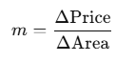

Which means: for every 1 sqft increase in area, the price increases by the value of the slope.

**Example**: If the slope is 1000, then for every additional square foot of area, the price will increase by 1000 INR.

**Intercept (b):**

* The **intercept** is the value of the **price** when the **area is 0** square feet. It is where the line crosses the y-axis.
* While the intercept might not have a practical real-world meaning (since a flat with 0 sqft doesn’t exist), it can represent things like **fixed costs** (e.g., registration, base construction cost) that are constant, regardless of the area.

**Example**: If the intercept is 50,000 INR, it means that the flat has a starting price of 50,000 INR even if it had no area (hypothetically). This could represent the base cost or minimum charge for the flat before considering its area.

**Solution:**

After performing the regression analysis on the data, you find the equation of the best-fit line to be:

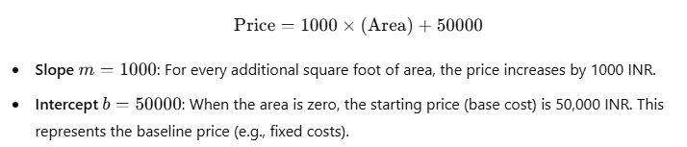

**Using the Model to Predict Price:**

